IMA Mira Bhayander RELAY - HUNGER STRIKE Held on 7th February 2021 at IMA Hall

7th Feb 2021, was designated to Women Doctors Wing & Mission Pink Health all over India to lead the relay hunger strike on National Presidents call.
IMA MIRABHAYANDER supported for movement against Mixopathy in full strength
The subject was covered by many press reporters from different news channels

Attended by
Dr Rakhi Agarwal (National Executive Member MPH /President Elect IMA Mira Bhayander), Dr Rajeev Agarwal (Treasurer IMA Maharashtra State), Dr Vivek Dwivedi (IMA MB President), Dr S R Desai (Past President), Dr Jiwarajka (Past President), Dr. Ashok Shukla (Chairman Medicolegal cell, IMA MS), Dr. Navneet Desai (Vice President IMA MB), Dr. Vikrant Desai (Past president IMA MB), Dr. Amol Jadhav (Jt Secretary), Dr Neeraj Jindal (Treasurer), Dr. Mangla Patil (Committee member) Dr. Jagruti Ghosh (Committee Member ) & others Dr. Ghosh, Dr.Rajesh Kumar Yadav, Dr. Harminder Singh.
We were Facebook live on NATIONAL IMA MPH Facebook Page for more than 16 minutes & Drs. spoke about effects of Mixopathy on Public Health
https://www.facebook.com/nationalimamph/videos/4026289567382291/
Press Conference held. 9 to 10 people from press were present. Prominent were Rajdev Tiwari, President of Journalists Association, Chandrakant Dubey of Saamana, Arun Upadhyay of Pravasi Sandesh, Arun Kaushik of Jeeya News. Many new channels covered the news.

The press club of Mira Bhayander fully endorsed the stand of IMA & they also sat with us for sometime in the relay hunger strike & they also openly gave a speech about their support to us

1)News Channel : SD NEWS GLAMOUR TIMES
News Link : https://youtu.be/dEsepIHDQac

2)News Channel : #IMA #JIANEWS
News Link : https://youtu.be/vC4Qb9g0gJw

3)News Channel : MY BKB (Bharat Ki Baat)
News Link : https://youtu.be/xctUDrljE_A

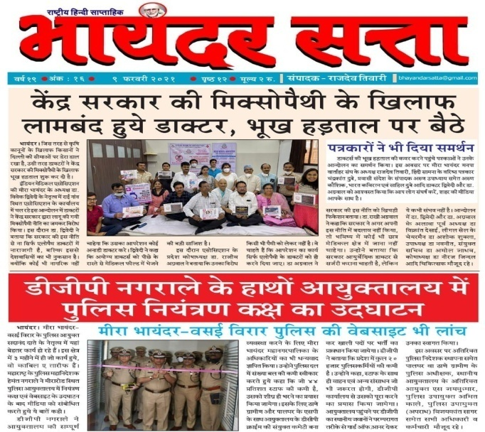 | 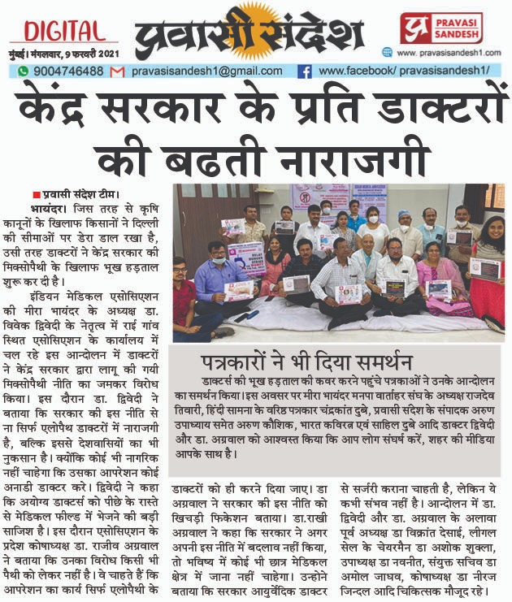
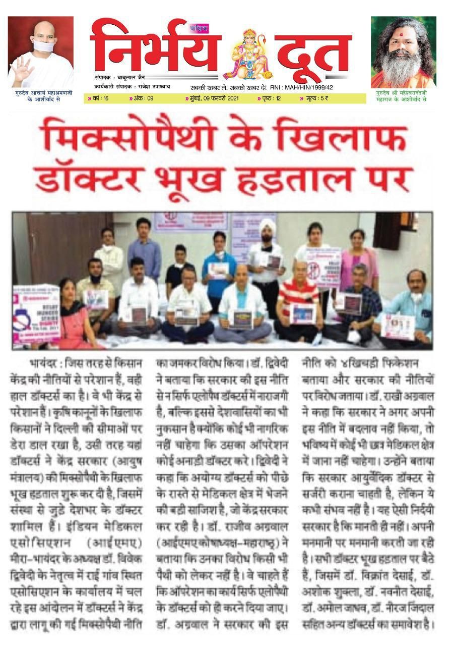 | 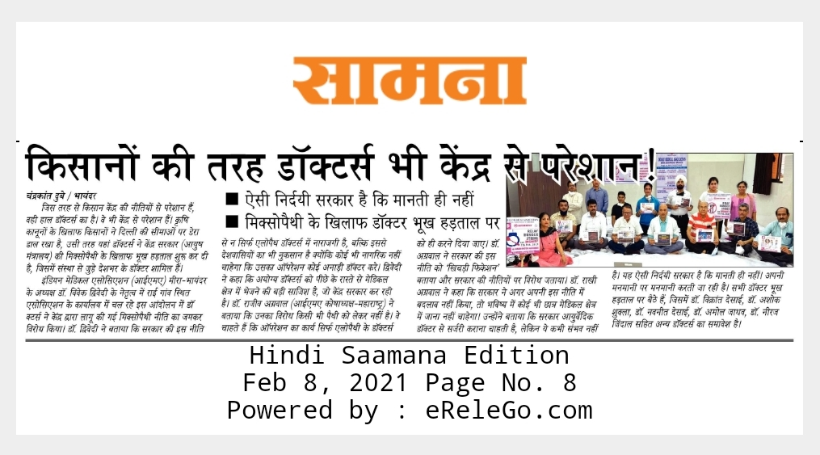

It was really overwhelming to see enthusiastic participation from Doctors & Media. It was a great show of strength & solidarity. Our aim was to spread awareness on the ill effects of Mixopathy & spread it to public through Media.

JAI IMA , LONG LIVE IMA

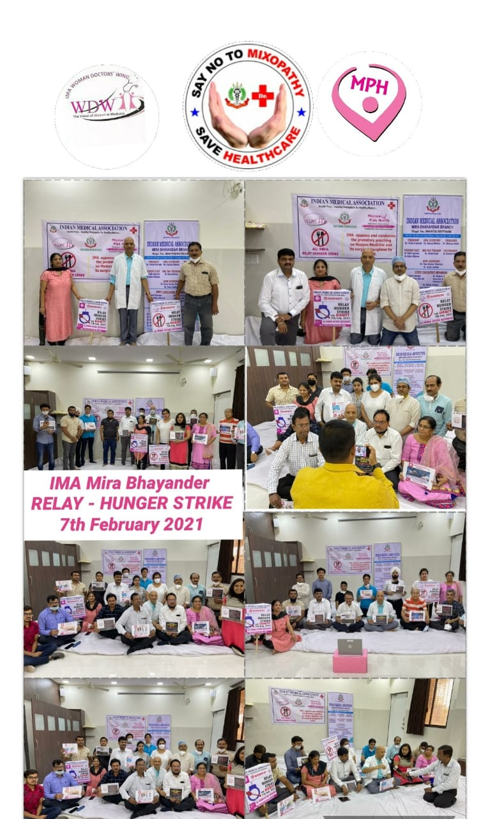

Other Work done for agitation against Mixopathy

1)Made petition for MPH from change of org.
http://chng.it/jV5rjXRp
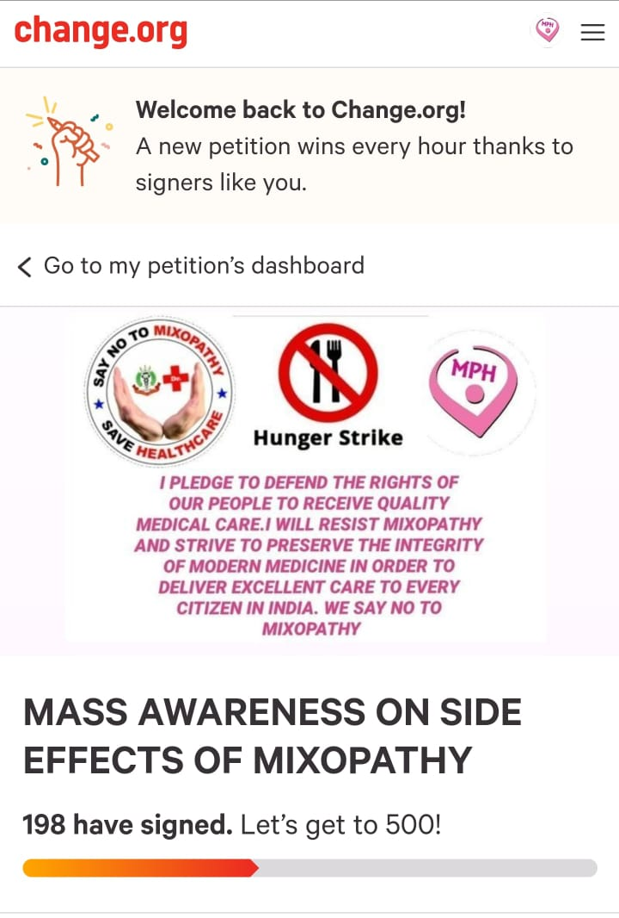 | 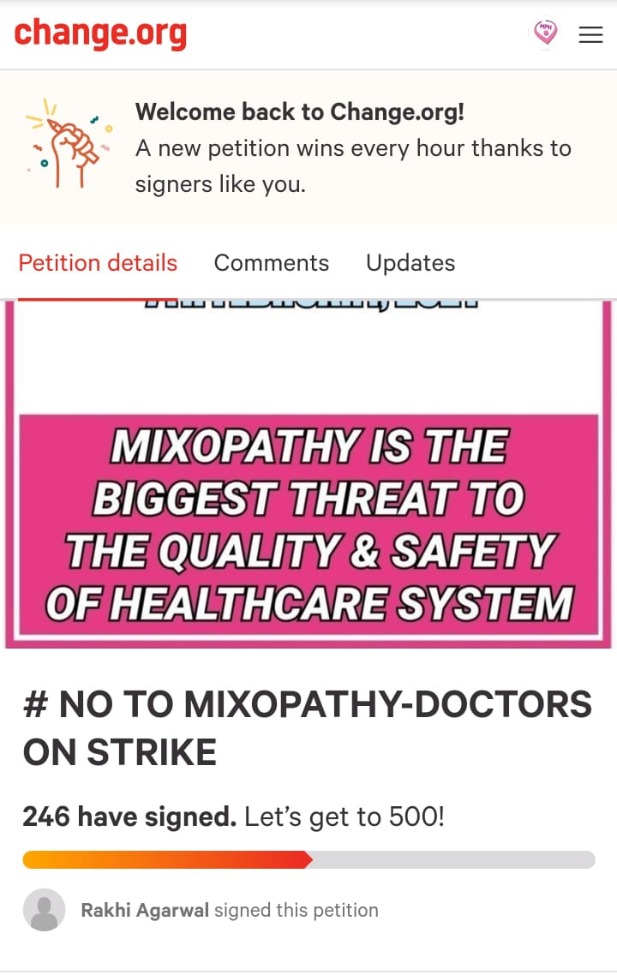

2)Made Fb profile pic with IMA & MPH Logo
http://www.facebook.com/profilepicframes/?selected_overlay_id=3956426037721886
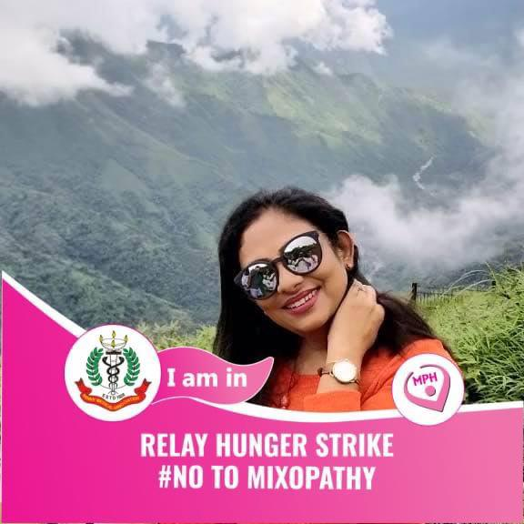 | 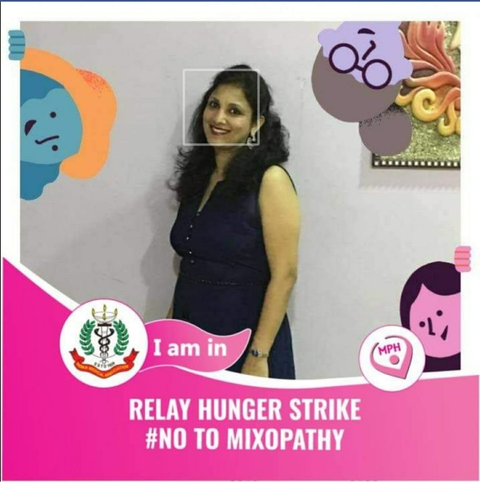

3)Designed few posters
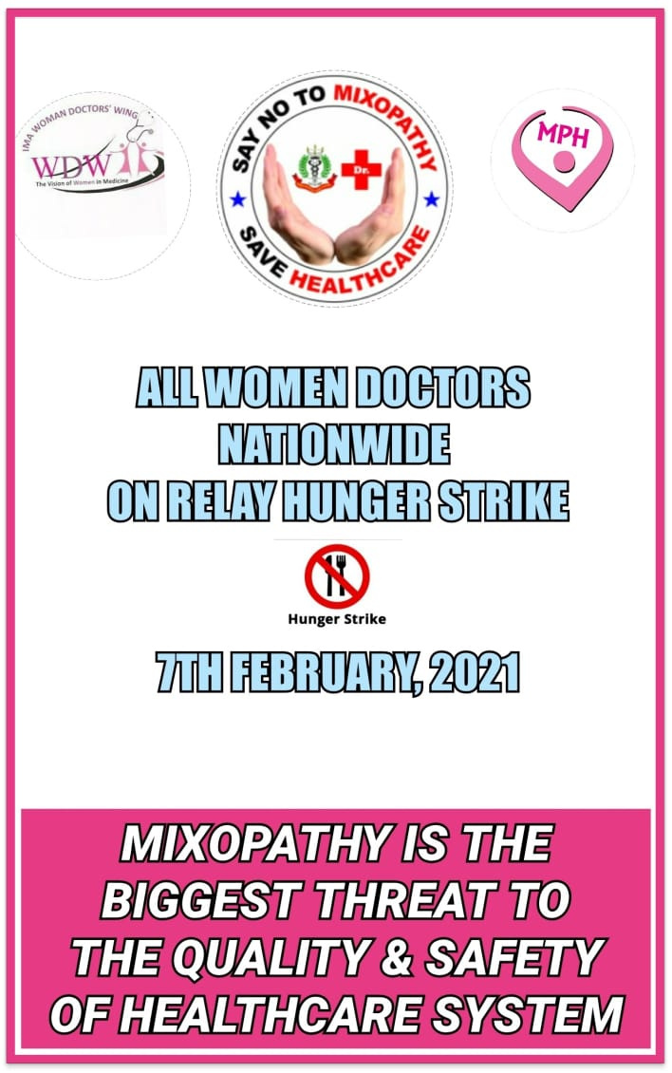
Dr Rakhi Agarwal (National Executive Member MPH /President Elect IMA Mira Bhayander)
Dr Rajeev Agarwal (Treasurer IMA Maharashtra State)

